Ecology South
Toledo Blade
November 2012

UT researchers study algae as economical biofuel
Significant federal funding pays for work
BY NOLAN ROSENKRANS
BLADE STAFF WRITER
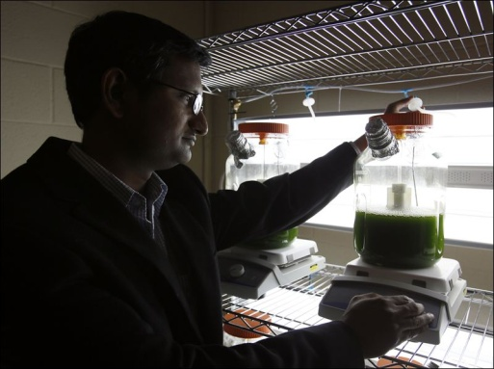
University of Toledo researchers are developing ways to convert algae into biofuels and have received significant federal funding for their work.
Sasidhar Varanasi and Sridhar Viamajala, members of the university’s chemical and environmental engineering faculty, were awarded a $3 million grant by the U.S. Department of Energy in September, and the pair, along with Kana Yamamoto, an assistant professor of chemistry at UT, also won a $1 million award from the National Science Foundation.
The group is researching ways to grow algae in wastewater, harvest the algae, and then break it down into fuels and chemicals. The process to turn algae into fuel is already known, but the researchers are trying to create ways to make the process more efficient and thus economically viable.
Food crops such as corn and soybeans are already used to create biofuels, but less work has been done with algae because it isn’t a readily available food crop.
“We are looking at algae at a different light,” Mr. Viamajala said. “It’s not a food crop, it’s a fuel crop.”
Mr. Viamajala said using algae instead of other sources for biofuels has several benefits. For one, algae don’t take up valuable crop space that could be used instead to grow food. Algae also don’t require high-quality water to grow, so wastewater or sea water could be used.
And because algae are structurally simpler than corn or soy, they grow more rapidly and could be more productive than those terrestrial plants.
Algae also don’t require fertilizer, which eventually ends up in rivers and lakes, to be spread on land.
“They ... can use waste nutrients,” Mr. Viamajala said.
Researchers are working on the fundamentals of the process and are probably three to four years away from it being economically viable.
The UT team is partnering with researchers at Montana State University and the University of North Carolina at Chapel Hill and with the city of Logan, Utah, and a
private Cleveland-based firm.
Work locally will be done mainly at UT’s Scott Park and Engineering campuses, Nagi Naganathan, dean of UT’s College of Engineering, said.
Their group isn’t the only one researching algae’s potential as a fuel source. The U.S. military, for instance, is investigating possible implementation of biofuels instead
of traditional fuel sources for such things as Navy ships, and algae may be among those sources.
Although UT’s researchers envision using facilities near wastewater plants and not collecting algae from places such as Lake Erie — its naturally occurring algae are
too diluted for harvesting purposes — the UT team’s system could help solve Lake Erie's algae problem.
What causes the increase in Lake Erie’s algae blooms in recent years is still not totally clear, but nutrients washed off from land into the lake are looked at as a prime
possible cause.
If that runoff is instead diverted to processing plants to help grow algae for biofuels, it would reduce the nutrient content in the lake.
If algae blooms then decreased, scientist would have new evidence that the nutrients are causing the blooms and would turn something with a negative environmental
impact into a postive.
“Here is a way we are able to convert what would otherwise be a societal nuisance into something that would be very valuable,” Mr. Naganathan said.

Contact Nolan Rosenkrans at: nrosenkrans@theblade.com or 419-724-6086.

