Electric Shock Drowning Gaining Attention Of Boating Community
By Bob Dohr, doorcountydailynews.com
http://www.doorcountydailynews.com/news/details.cfm?clientid=28&id=86879#.Ufl70m_D_mJ

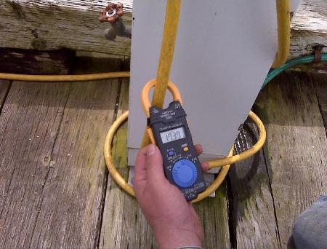
A danger involving boats, swimmers, fresh water, and electricity has been getting more attention from members of the boating community.
It's called Electric Shock Drowning (ESD), a catchall term that includes in-water electrocution and drowning that's the result of becoming paralyzed by electricity in the water.
Dr. Alan Wentworth, a Door County Sail & Power Squadron member, says he started learning more about ESD earlier this year when stories about it started popping up in boating magazines. One such article focused on the story of Kevin Ritz, who lost his eight-year-old son to ESD in 1999. (Does Death Lurk Below? Electric Shock Drowning: A Deadly Dockside Danger, Boating Magazine, May 2013)
Wentworth says reading that account compelled him to schedule Ritz to speak at the Power Squadron's spring district conference in Minneapolis. Wentworth says Ritz's presentation was eye-opening.
Lucas Ritz's death was originally ruled a drowning until further investigation determined it was ESD.
Wentworth has first-hand knowledge of the types of dangers that can arise where people, water, and electricity meet. He says a number of years ago his daughter suffered a frightening electrical shock while swimming at the marina in Egg Harbor.
Wentworth says several steps can be taken to prevent ESD. A simple but important one is to stay out of the water around marinas.
Wentworth says another measure recommended by Ritz and the American Boat & Yacht Council (ABYC) is installing a ground fault interrupter device at the pedestals at the docks that can interrupt the current supply when there is a ground fault that will electrify the water.
"The third thing that we recommend from a medical standpoint is that all marinas have automatic defibrillators available," says Wentworth. "So if a person does sustain ventricular fibrillation the defibrillator device is available. This coupled with CPR is a very effective way of treating these people."
As for boaters, Wentworth says they can use an inexpensive clamp-on current measuring device to make sure their crafts are wired safely.
"If the clamp-on meter reads zero or close to zero when it encompasses your power cord to shore that pretty well assures you there isn't a ground fault or a leakage from your boat into the water," says Wentworth. "It doesn't assure you that there isn't such leakage from some other boats but at least you can check your own boat that way."
The conditions necessary to create an in-the-water shock hazard apply to docks, boats, irrigation pumps, fountains, and any place where you have AC and fresh water. Two general failures are necessary: 1). The lack of or failure in the AC grounding/bonding system. 2). An electrical fault (i.e., a short circuit).
Source: www.abycinc.org
