NASBLA Currents
July 2013

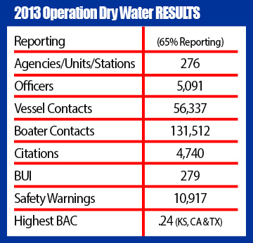
Operation Dry Water 2013 update
National Association of State Boating Law Administrators
Operation Dry Water reports are coming in from agencies across the country who participated in ODW2013 activities. Currently 276 agencies (65 percent of registered agencies) have reported. As of today, 279 BUIs were reported during the Operation Dry Water weekend with the highest BAC level coming in at 0.24. Going into Operation Dry Water 2013 weekend, 421 agencies were registered for the campaign's activities in all 50 states as well as four U.S. territories and British Columbia. This includes local, state and federal law enforcement agencies, including the U.S. Coast Guard.

