Provided by Michigan Boating Industries Association:
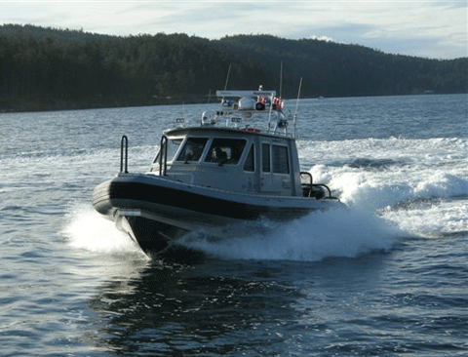
- U.S. - Canada Shiprider - Officially known as Integrated Cross-border Maritime Law Enforcement Operations (ICMLEO), represents a truly cooperative approach to combating cross border crime on Canada and U.S. shared waterways. The Shiprider removes the international maritime boundary as a barrier to law enforcement by enabling seamless continuity of enforcement and security operations across the border, facilitating cross-border surveillance and interdiction, and serving as both a force multiplier and, potentially, as a model for other U.S./Canadian cross-border (integrated) enforcement and security initiatives. For more information visit MBIA.org.
- Don't forget when boating in Canadian waters - you must report your vessel, even when not planning to "land"
From the Canada Border Patrol, regarding reporting your vessel to the proper authorizes:
  - Planning to "land" your vessel on Canadian soil or did you leave Canadian waters and land on U.S. soil?All private boaters who intend to land on Canadian soil are required to report to a CBSA designated marine reporting site. Upon arrival at a CBSA designated marine reporting site, call the Telephone Reporting Centre (TRC) at 1-888-226-7277 from the phone provided to obtain clearance.
  - Not planning to "land" your vessel or did you leave Canadian waters but did not land on U.S. soil? You still need to report to the CBSA. Certain private boaters may contact the CBSA by calling the TRC at 1-888-226-7277 from their cellular telephones upon arrival in Canadian waters. This includes: Canadian citizens and permanent residents who have not landed on U.S. soil; and U.S. citizens and permanent residents who do not plan on landing on Canadian soil. Private boaters that are strictly weaving in and out of Canadian waters but are not in transit, are required to call the TRC only once at the time of their initial entry into Canadian waters. For more information visit: http://www.cbsa-asfc.gc.ca/mobile/pbt-plp-eng.html.

