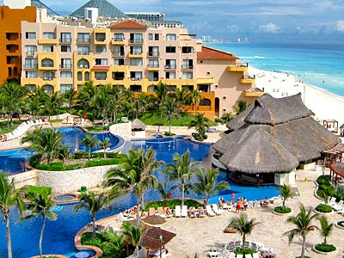
AYC 2016 CLASS TRIP
MARCH 11 – 18, 2017
Join Commodore
Dennis Proctor and Lady Pat
for an unforgettable week in Cancun

NEW LOWER RATES!

INCLUDED IN YOUR PACKAGE
-Seven (7) night accommodations in Cancun at the ALL INCLUSIVE Fiesta Americana Condesa Cancun
502 Air conditioned rooms with 2 double beds or one king, TV, mini fridge, in room safe, and hair dryers.
All Inclusive:
All meals and drinks
-12 restaurants including Italian, Mexican, Argentinean Steakhouse and Asian
-AYC Cocktail Party
- 24-hour room service (surcharge for premium brands and by the bottle)
-High speed wireless internet in public areas and room included
-6 bars including Lobby, swim up and beach bar
-Daily hotel activities and entertainment
- Round trip airport transfers
-Complimentary T-shirt
Hotel and Transfer rates: Per person, based on double occupancy
Superior garden view $1,094.00
Deluxe sunset Lagoon view $1,161.00
Deluxe Ocean view $1,430.00
Deposit is $250.00 per person at time of reservation
Final payment is due November 4, 2016

AIRFARE, add $657.20 per person for these Delta nonstop flights:
March 11 Delta 713 Detroit/Cancun 10:15am – 2:11pm
March 18 Delta 677 Cancun/Detroit 3:54pm – 8:45pm
We can only guarantee the first 50 seats at this airfare!
The next 50 seats will be a higher airfare.
***You are not obligated to purchase the airfare we have blocked with Delta.
SPACE IS LIMITED!
ANY QUESTIONS OR TO SIGN UP ……..CALL ANGELA AT
VOLARE TRAVEL (586) 263-4500

RESERVATION FORM AYC CANCUN

DEPOSIT: $250.00 PER PERSON
FINAL: November 4, 2016

NAMES AS APPEARS ON PASSPORT AND DATE OF BIRTH:

1st Passenger______________________________________________DOB_______________

2nd Passenger_____________________________________________DOB_______________

Mailing Address______________________________________________________________

City________________________________State________________ZIP__________________

Daytime Phone_____________________________Cell________________________________

Email________________________________________________________________________

T-SHIRT SIZE(S)___________ _______________ REQUESTS___________________________

Attached check in the amount of __________________Payable to Volare Travel

For Credit Card Payments:
Name of Credit Card____________________________________________________________

Card Number _________________________________________________________________

Expiration Date______________________________Security Code_______________________

Signature__________________________________________Date_______________________

Mail to: Angela Alongi You will get a refund for the comp
Volare Travel trips earned – could be up to $50.00
42500 Hayes Suite 400 per person, amount is based on size
Clinton Twp, MI 48038 of group (paid prior to departure)
(586) 263-4500

