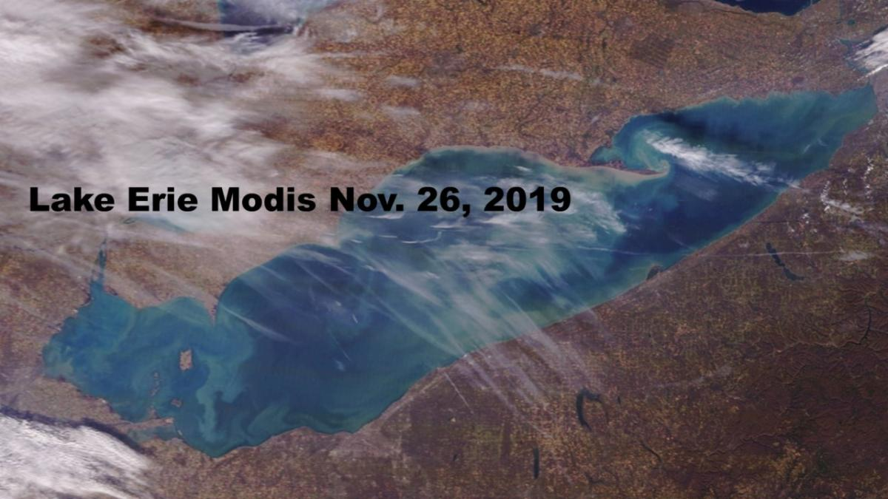
A beautiful blue
Lake Erie
November 26, 2019 MODIS

Help Lake Erie
Donate to Lake Erie Waterkeeper on Giving Tuesday/Holiday Season
Donations of $25 or more - 2020 Lake Erie Lighthouse Calendar and Qualify for $5000 grant drawing by Toledo Community Foundation. Thanks for your support

Lake Erie Waterkeeper Meeting December 12
Speaker Scott Butterworth, ODNR District Manager of Wildlife on H2O ODNR funding allocation of $46.2 million at 7 pm at Manos Upstairs at 17 ^{th} & Adams Toledo. A Lake Erie Round Table discussion will follow.

A Note from Sandy Bihn Lake Erie Waterkeeper:
Mother Nature, as harsh as it was on farming in Western Lake Erie, taught us a lesson that we need to heed. About half the commercial fertilizer with phosphorous and nitrogen was not applied to the fields yet we had the fifth largest algal bloom. And farmers using commercial fertilizer in western Erie have reduced the amount of phosphorous use by 30-50%. These two factors are more than H2O Ohio and other programs are projecting to reduce phosphorous. The reality is that manure applications from a growing livestock business is land applied that continues when crops are not planted. The answer is to treat the manure to municipal waste water treatment standards and not allow excess phosphorous applications.
Meat and Dairy lobbying is as big or bigger than the NRA. To address the growing manure problem, I am teaming with national groups to spotlight and call out the water related problems land application of manure is causing. Therefore in the Lake Erie updates, you will see national articles, studies etc. that relate to manure.
Ohioans please consider signing the letter to Governor DeWine asking for treatment and less phosphorous and ask your local government to pass a resolution with the same request. It will take a lot of us for action on manure, which Ohio is refusing to address, to help Lake Erie and all Ohio waters.

Lake Erie Updates
- Study shows Lake Erie Economic Cost/Benefit Reducing Algae
- Ohio Department of Agriculture watershed planning Senate Bill 2 Ohio Ag watching ag - Fox watching hen house
- Nations Leading Health Organizations asking for Moratorium on new and expanding CAFO’s
- Romaine lettuce do not eat, study shows Concentrated Animal Feeding Operations should not be located so close
- Great Lakes Water Levels outlook - ﻿ It keeps raining and the snow keeps falling - spring 2020 flooding may be worse than 2019 - not good

3900 N. Summit  Toledo, Ohio 43611  ﻿888-519-1142 | ‌ ‌ ‌

