Report from Lake Erie Waterkeepers Delegate Phil LaCourse
September 15, 2019
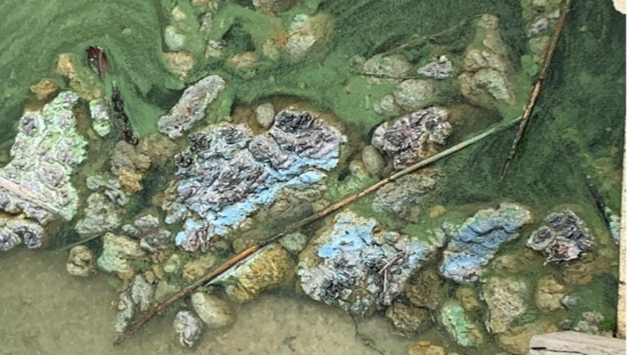 | Picture of what appeared to be and smelled like human sewage at Harbor View Yacht Club. Ohio E.P.A. tested and said it is decaying algae.

Lake Erie Waterkeeper meeting Thursday, September 12 at 7 pm at Toledo Yacht Club, 3900 N. Summit Toledo, Ohio.
Guest Speaker Rep. Paula Hicks Hudson followed by Lake Erie Round-table Agenda

Ohio Department of Agriculture(ODA) issues draft permit to add 9600 hogs t ﻿ hat will apply 3.2 million gallons of manureand estimated 57 tons of phosphorous to the Auglaize/Maumee Lake Erie watershed where Ohio EPA and others has recommended reducing phosphorous.

Study finds Stopping Asian Carp from entering Great Lakes is because of polluted water from the Chicago waterway .

Treating Lake Erie water for drinking - Ottawa County

France algae fumes cause human and animal deaths - close beaches

Lake Erie satellite image September 11, 2019. NOAA Lake Erie HAB Bulletin

The Ohio Lake Erie Commission will meet on Wednesday, September 18 at 10 am in Lorraine, Ohio.

The Thursday, October 10 Lake Erie Waterkeeper meeting at 7 pm at Toledo Yacht Club will have Ohio Lake Erie Commission Director Joy Mullinex as guest speaker. The meeting will be followed by a Lake Erie Roundtable discussion.

