Report from Lake Erie Waterkeepers Delegate Phil LaCourse
August 31, 2019
Donate

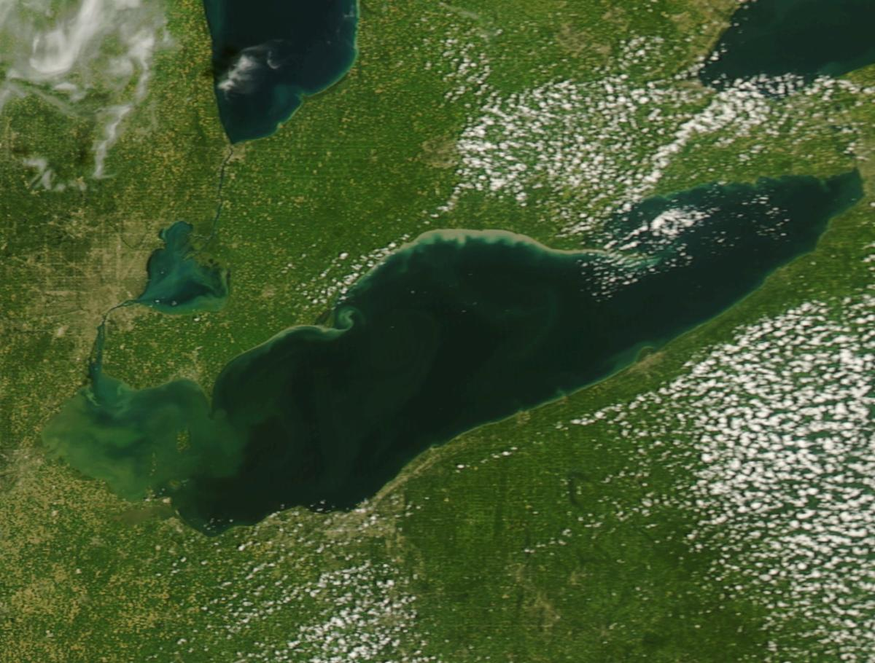

Above Lake Erie NOAA MODIS AUGUST 29, 2019

Hoping all will have an enjoyable weekend on our Great Lake Erie and that the algae does not limit fishing, boating etc.

I received some interesting information on algae USA - pictures, challenges, and news articles(links below). Maybe there is some solace in us not being alone with the algae challenges.

Toxic Algae USA Coast to Coast pictures

Algae 101 Information

Algae USA news Articles August 2019

The 4th Annual OSU Lake Erie Algae Conference is Sept. 12 in Toledo. Cost is $40 . There is a lot of information provided at this conference that may be of interest.

The next Lake Erie Waterkeeper meeting is Thursday, September 12
at Toledo Yacht Club at 7 pm with guest speaker Ohio Rep. Paula Hicks Hudson, former mayor of Toledo followed by a Lake Erie Roundtable.

The Thursday, October 10 Lake Erie Waterkeeper meeting at 7 pm at Toledo Yacht Club
guest speaker will be Ohio Lake Erie Commission Director Joy Mullinex. The meeting will be followed by a Lake Erie Roundtable discussion.

3900 N. Summit  Toledo, Ohio 43611  ﻿888-519-1142 | ‌ ‌ ‌

