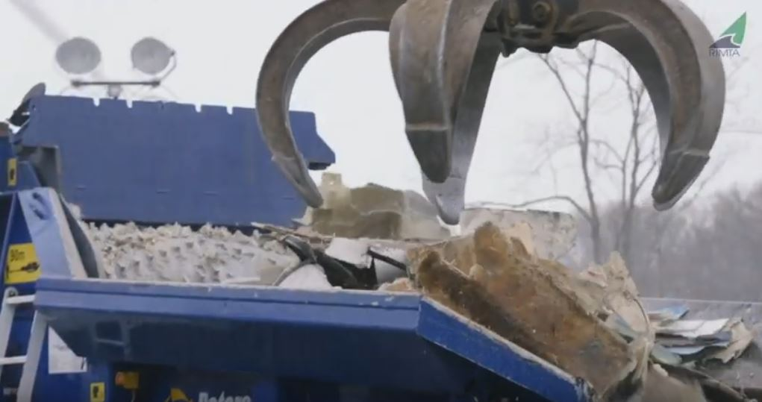
Photo Caption: End-of-life fiberglass boat hulls are processed into material for use in cement manufacturing.
[Video] Facing the Legacy: Lifecycle Solutions for Fiberglass Boats
Rhode Island Marine Trade Industry Association
aims to grow boat recycling across U.S. with novel pilot program
PROVIDENCE, R.I., August 11, 2020 – With the move to phase 2 of the Rhode Island Fiberglass Vessel Recycling (RIFVR) Pilot Program to address the disposal issue of recreational boats, project managers have released “Facing the Legacy: Lifecycle Solutions for Fiberglass Boats.” The short video shares the compelling story of how those efforts have evolved into a first-in-the-nation boat recycling project.
Many fiberglass recreational boats end up in a landfill or abandoned. “Boatbuilders, boat owners and boat businesses alike face limited options for responsible disposal,” says video narrator Evan Ridley, Rhode Island Marine Trades Association’s Director of Environmental Programs.
BoatUS Foundation for Boating Safety and Clean Water’s Director of Outreach Alanna Keating, whose organization provided Grassroot Grant funding for the project, adds, “We get calls from boaters across the country wondering what they can do with their unwanted boats.” The boatbuilding boom of the 1970s, ’80s and ’90s has led to a large number of fiberglass recreational boats reaching end of life. Hurricane activity also continues to add to boat abandonment and disposal challenges.
Completed in 2019, phase 1 of the project included collecting 20 tons of recycled recreational boat material, processing it, and suppling the product to concrete plants. The recycled boat material is used both as an energy source and as a filler for concrete manufacturing.
Phase 2 will include an economic analysis of the pilot program to help determine long-term feasibility, legislation opportunities and regulations supportive of fiberglass boat recycling, lessons learned, and resources to aid other fiberglass recycling programs.
The pilot program was made possible with support from 11th Hour Racing, the Association of Marina Industries, Rhode Island Resource Recovery Corporation, and the BoatUS Foundation Grassroots Grant Program. For more than 25 years, the nonprofit BoatUS Foundation has awarded more than a million dollars to local community organizations, yacht clubs, flotillas and squadrons that promote safe and clean boating on local waterways. To learn more about how to tap into BoatUS Foundation Grassroots Grants, go to BoatUS.org/Grants
###
Suggested Tweet and Facebook post:
What happens when fiberglass boats reach the end of life? A new video offers a look at a first-in-the-nation recreational boat recycling program https://bit.ly/3gPGbYs @BoatUSFoundation @RIMarineTrades
About the BoatUS Foundation for Boating Safety and Clean Water:
The BoatUS Foundation for Boating Safety and Clean Water is a national leader promoting safe, clean and responsible boating. Funded primarily by donations from the more than half-million members of Boat Owners Association of The United States (BoatUS), the nonprofit provides innovative educational outreach directly to boaters and anglers with the aim of reducing accidents and fatalities, increasing stewardship of America's waterways and keeping boating safe for all. A range of boating safety courses – including 36 free state courses – can be found at BoatUS.org/Courses.

