MRYC Presents
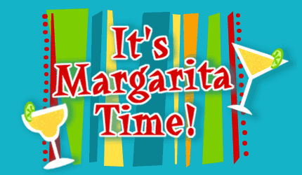
That’s right!!
The 7th Annual
MARGARITA PARTY
and TASTE OFF!
April 14th at 6pm
$15 cover charge – Includes Mexican Buffet and Snacks
$5 per Margarita Flight of 6 Tastings and 1 Vote
Multiple flights can be purchased!!! Buy the Trophy!!
Polls close at 9pm for award ceremony!!
Individual margs can be purchased for $5 after awards.

WE NEED 6 ENTRIES, SEE BARTENDERS FOR RULES!!

