SWAN BOAT CLUB'S 2017 Wild Game Dinner Menu
Saturday: December 2nd, 2017
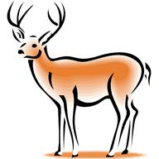Hors d oeuvres 5:30pm
Norwegian Smoked Salmon
Alligator
Cream Herring
Turtle Soup
Venison Chili
Hot Wild Wings
Venison jerky
Assorted cheeses, crackers, sausages, nuts & veggies

Dinner Buffet 7:00pm

Chef Carved Buffalo with AuJus and Fresh Horseradish Sauce
Rabbit Stroganoff with Long Grain & Wild Rice
Moose Tips with Buttered Noodles
Venison Sesame Roll with Gravy
Venison Lasagna
Teriyaki Orange Duck
Boar Marsala
Herb Chicken

Sides

Garlic Mashed Potatoes and Gravy, Corn, Tossed Salad, Michigan Cherry Vinaigrette Slaw, Rolls & Butter
Assorted Cookies and Apple Pie, Brownies, Coffee and Tea

Draft Beer and Fountain Pop included.
*Cash Bar Available

