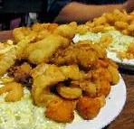

**Where: RVYC**

**When: 2/17, 2/24, 3/9, and 3/16**

**Time: 5:30 till gone**

**Price: $10.00 for Fish**

**$13.00 for a Steak**

**RVYC Commodores Ball**

**All you can eat Fish dinner or**

**Order a Steak to your liking**

