Monroe Boat Club Regatta
“Open to the public, come and enjoy”

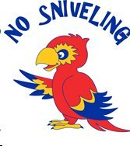
JULY 22th 5 pm – 1 am
JULY 23th 9 am – 1 am
****************************************************************************************************************************************
“Emerging Soul Band” Friday: 9pm – midnight
“Soul Kitchen Band” Saturday: 6pm – 8pm
“Lazy River Band” Saturday: 9pm – Midnight

Constant music throughout the entire weekend!

***************************************************************************************************************************************
GREAT FOOD! – GREAT FUN!
* Ice Cold Beers and Special Boat Club Cocktails
*Delicious Variety of Outside Food
*Breakfast Sat. & Sun. AM
*Auction Saturday at 4:00pm under the Big Tent

Special thanks to 98.3 Nash Icon for the live remotes!
Mary Sacco world famous Pizza both nights, 10 pm. to Midnight
Nick and Nino’s Street Food Sat. 4-10 pm.

