MAUMEE RIVER YACHT CLUB
PRESENTS
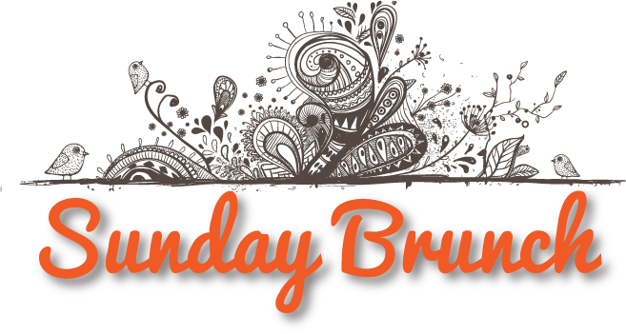
THE FIRST SUNDAY OF EACH MONTH
Bring your friends and family down to enjoy Chef Bill Bartlett’s fine selection of all your favorite brunch delicacies with adult and kid pricing and a beautiful view of the river!

Please place your reservations early to guarantee a table and room for docking!!
419-382-3625

