OOTI
WYC Famous Fish Fry

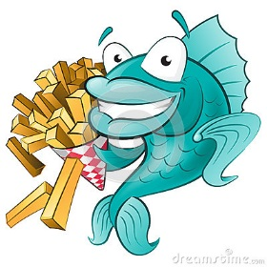
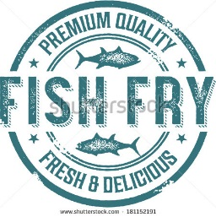

Friday, June 5, 2015
Dinner 6-9 pm (or until sold out)
DJ Scott 7pm –Midnight

Dinner includes
2 pieces of WYC Secret Recipe Beer Battered
Weylend’s Atlantic Cod
Tony Granelli’s famous Cole slaw, fries, roll and dessert.

$13 per person

BYO Beer, bottle, booze!

For Information contact VC Dawn Schaumburger 734-558-6129
Located at Wyandotte Yacht Club 3 James DeSana Drive, Wyandotte, MI

