MRYC Presents
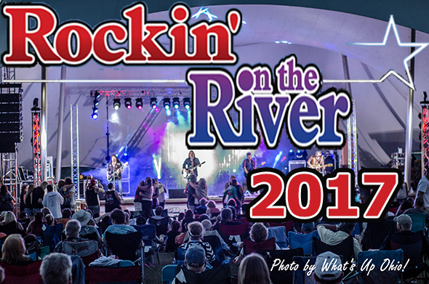
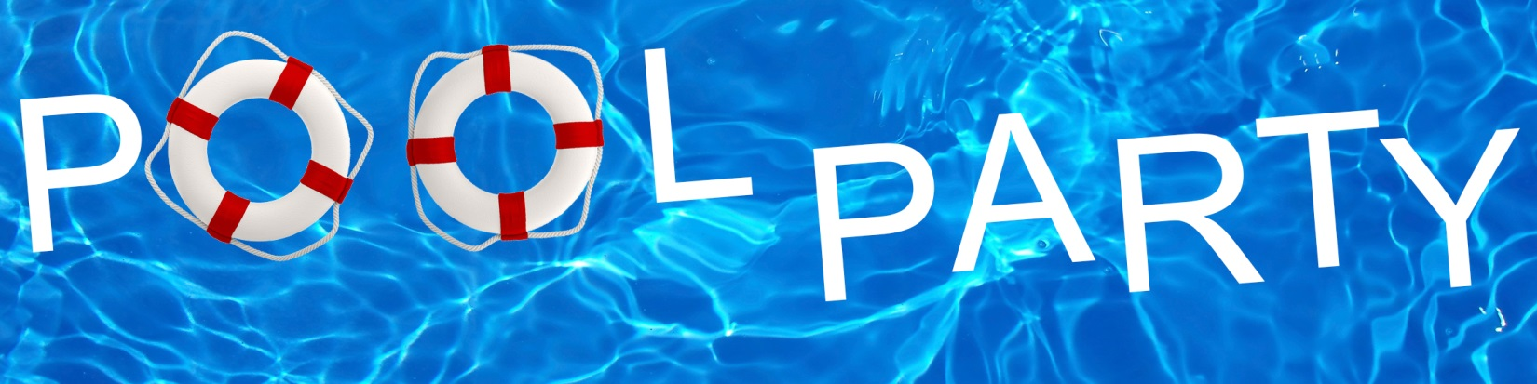
June 3rd all day long!!
That’s right, bands all day at the pool!!
Starting off with the award winning blues and rock band PERCEPTION and rocking into the night with 3 HORSEMEN!!
The BBQ Grill will be open featuring ribs, burgers, brats, etc.!!
Contests: Biggest Splash, hula-hoop and water balloon toss
Basket Raffles, Lottery Ticket Raffle and 50/50

