OOTI
WYC Famous Fish Fry

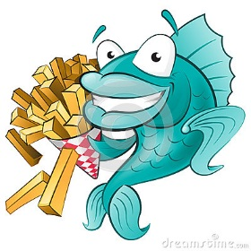
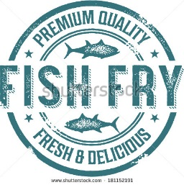

Friday, June 9, 2017
Dinner 6-9 pm (or until sold out)

@
Wyandotte Knights of Columbus
3530 Biddle Ave. Wyn. MI 48192
(Located South of Eureka Road)
Dinner includes
2 pieces of WYC Secret Recipe Beer Battered
Weyand’s Atlantic Cod
Tony Granelli’s famous Cole slaw, fries, roll and dessert.
$13 per person
Open Juke Box for your listening and dancing enjoyment
SHUTTLE SERVICE FROM FYC, EMBC & GIYC TO WYC FISH FRY
CALL/TEXT LISA VILELLA aka Mimi @ 734-282-2462

For Information on the Fish Fry contact VC Robert “Bobber” Spicer 734-934-7314

