SWAN BOAT CLUB
invites you to join us for our
FAMOUS FISH DINNERS
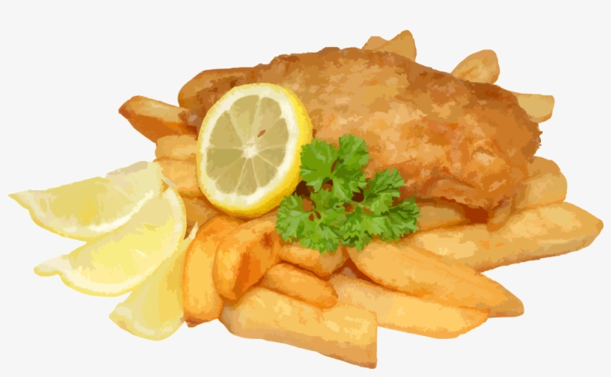
Fish Fried and Baked
Potatoes Fresh cut French Fries or Baked
Cole Slaw and Rolls
5PM

March 19, 26 and Good Friday April 2
$12
(Large groups, please call VC Rick Liberty 734-673-0475
in advance to arrange seating)

