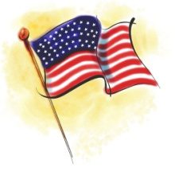 Harbor View Yacht ClubC:\Documents and Settings\jpetersberger\Local Settings\Temporary Internet Files\Content.IE5\LL8INFXZ\MC900174377[1].wmf

Blue Gavel Presents

Baby Back Rib Barbeque & Brews

Memorial Day Weekend May 23th 2015

DINNER MENU

½ Slab Baby Back Ribs, Sweet Corn, Potato Salad with Roll $10

OR

Barbeque Chicken Breast, Sweet Corn, Potato Salad & Roll $9

[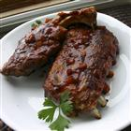](http://allrecipes.com/recipe/scott-hibbs-amazing-whisky-grilled-baby-back-ribs/photo-gallery.aspx) C:\Documents and Settings\jpetersberger\Local Settings\Temporary Internet Files\Content.IE5\27D4E2JQ\MC900336044[1].wmfC:\Documents and Settings\jpetersberger\Local Settings\Temporary Internet Files\Content.IE5\FP3TL4FF\MC900281074[1].wmf

Entertainment we be provided by, The East River Drive Band

Dinner starts at 5:00pm till all the bones are gone!

Please make you Reservation on the signup sheet so you’re not left with just a brew!!!

Reservations; Joe Petersberger 419-262-2439

Walk-ins welcome