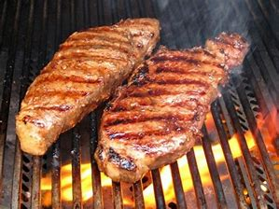

Swan Boat Club Announces-Steak Roast Season
Opening Day May 10, 2019
Friday Nights at 5:30

STEAK DINNER WITH ALL THE TRIMMINGS!

Strip/Ribeye - $11 Filet - $12
Chicken - $8

May 10th, 17th Memorial Day May 27th;
June 7th, 14th, 21st, Thursday, pre-regatta June 27th;
July 12th, 19th, 26th, August 9th, 16th, 23rd and September 6th
“Come Join Us”

