2022 Steak Roasts will begin at
SWAN BOAT CLUB on
FRIDAY, MAY 20TH 5:30pm-7:30pm
$15.00
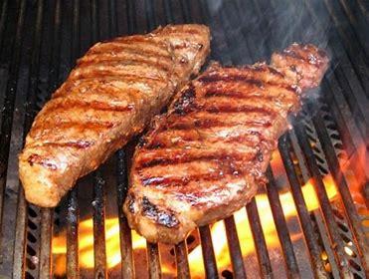
Chicken Breast and Salmon are also available.
We will also offer Shrimp as an ADD ON to your dinner. All dinners include sides.
NEW KIDS MENU $5.00 (available for up to age 12)
2022 Steak Roast Dates: May 20, 30, June 3, 10, 17,
24, 30 July 8, 15, 22, Aug 12, 19, 26, Sept 2, 9
.
(Blue Gavel Rib Dinners Friday: May 27, July 1, Aug 5)
*Large group seating please call VC Chris 734-735-4617 by Wednesday

