Fundraiser for VC Dawn Schaumburger’s
Commodore Ball in 2016
Friday, November 13th at 7:30pm
Wyandotte K of C Hall
3530 Biddle Av. Wyandotte, MI”
Includes Appetizers and desserts
Cash Bar
$25 per person

Call or email RC Vivian Gebstadt to reserve your spot and make your selection now as we have limited seating!
(313) 682-4113 or david48@comcast.net

You may pick from 3 choices to paint:

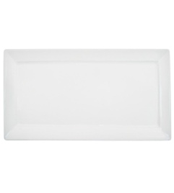
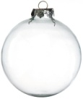
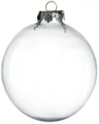
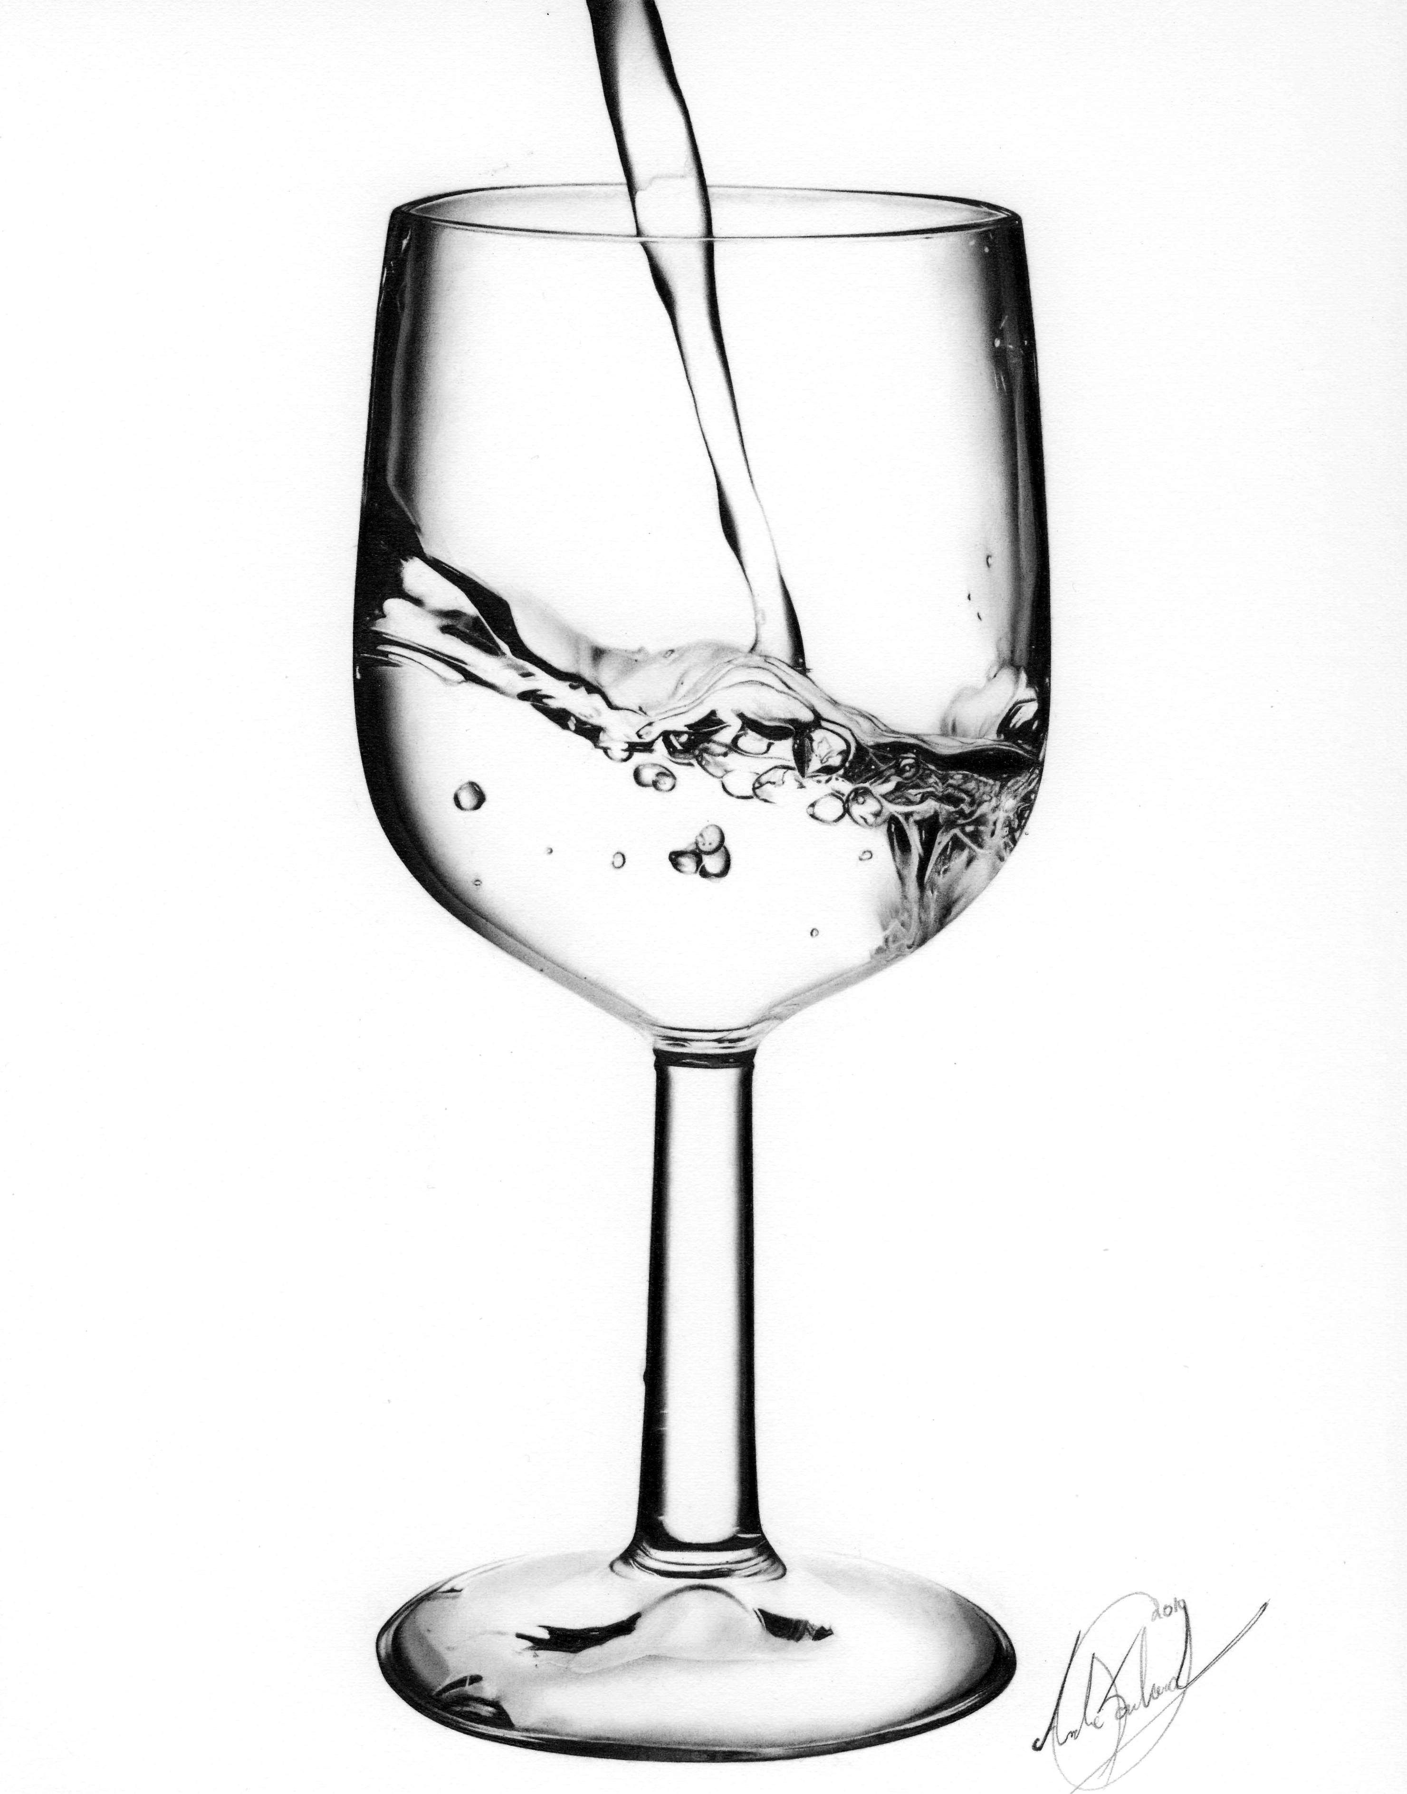

2 wine glasses 2 ornaments 12 in X 6 in appetizer plate

