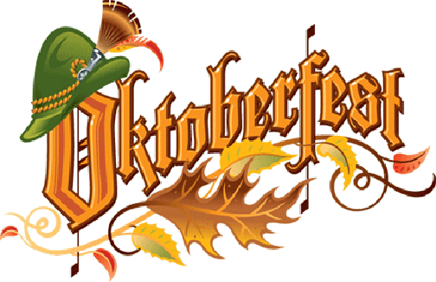
RVYC Oktoberfest
October 24, 2015
Program
5:00 – 7:00 PM Recorded German Music
7:00 PM – 11:00 PM Music by “Encore” Band
8:00 PM Toledo Holzhacker Buam Schuhplattler Dance Group
9:30 PM Toledo Holzhacker Buam Schuhplattler Dance Group
11:00 PM – 12:00 PM Recorded German Music

Menu
Serving from 5:00 – 8:00 PM
Ham Hocks
Bratwursts
Smoked Sausage
Chicken Schnitzel
German Potato Salad and Sauerkraut

Beverages
German Biers
Asbach Jagermeister Rumple Minz Goldschlager
Peppermint Schnapps
German Brandy
Herbal Liqueur
Cinnamon Schnapps

