SWAN BOAT CLUB LABOR DAY WEEKEND
SATURDAY NIGHT LASAGNE DINNER

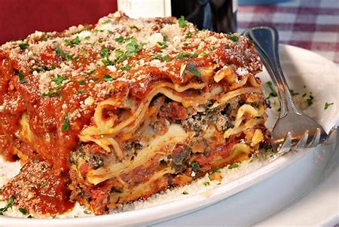
Saturday Sept 3rd 5:30-7:30PM
Adults $10 Children under 10 $5
Dinner includes:
Lasagne, Garlic Bread and Salad

Entertainment: Cruisin’ Jupiter 8PM-midnight

Pizza 9pm-11pm $3.00 per slice
Questions? Contact VC Chris 734-735-4617

