Swan Boat Club Labor Day Weekend
Sunday Traditional Pig Roast Dinner
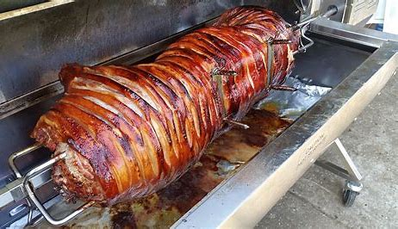
Sunday, Sept 4th 5pm-7pm
Dinner will include:
Roasted Pork, baked beans, cole slaw,
rolls and butter
Adults: $15
Children under 10 $10
(No sharing No carry outs)
Questions, call VC Chris 734-735-4617

