Ecology South
July 2012

Printed Friday, July 13, 2012

Canada concurs on Asian carp

Fish present threat to Great Lakes

BY MATT MARKEY
BLADE OUTDOORS EDITOR

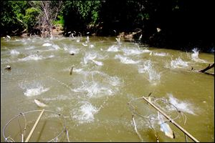
Asian carp, jolted by an electric current from a research boat, jump from the
Illinois River last month near Havana, Ill.
A study released Thursday by Fisheries and Oceans Canada paints a very grim
picture of the threat posed to the Great Lakes by invasive Asian carp, and
states that the likelihood of the fish entering the Great Lakes is "very high."

The study, titled "Binational Ecological Risk Assessment of Bigheaded Carps for
the Great Lakes Basin" concluded that the presence of as few as 10 females and
10 or fewer male Asian carp would be enough to allow the fish to reproduce in
any of the Great Lakes.

In a repeat of the findings of earlier studies done in the U.S., the Canadian
officials concluded that should the carp get into the Great Lakes, the fish
would find Lake Erie "attractive and favorable," and they would spread more
rapidly throughout Lake Erie than in some of the other deeper, colder lakes.

"The report underscores the severity of the Asian carp threat and the need for
leadership so that we can solve the problem once and for all," said Andy
Buchsbaum, director of the National Wildlife Federation's Great Lakes office in
Ann Arbor.

The Canadian study concluded that the Chicago canal network, that controversial
man-made link between the Great Lakes and a Mississippi River system that is
overrun with Asian carp, is the likely point of entry for the fish into the
Great Lakes, with a "very high" probability of that occurring.

The carp are thought to be currently just a few miles from Lake Michigan,
restrained only by an electrical barrier in the Chicago waterway, but many
involved parties have raised serious questions about the reliability of the
invisible fence.

"The Asian carp are moving toward the Great Lakes far faster than the government
response, and this report shows that the cost of inaction will be devastating,"
Buchsbaum said. "President Obama and Gov. Romney need to declare that they will
take the necessary action to build an effective physical barrier to keep the
Asian carp out of the Great Lakes."
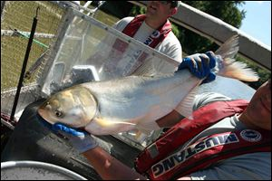

Asian carp are considered to present the most serious threat to the $7 billion
sportfishing industry on the Great Lakes.
Asian carp is the collective term used for four species of the invasive fish:
Grass carp, black carp, silver carp and bighead carp. In the Fisheries and
Oceans Canada document, silver carp and bighead carp are referred to as
"bigheaded carps."

Bighead carp commonly reach 40 pounds and can grow to 100 pounds. Silver carp
reach about 20 pounds and are infamous for the panicked leaps they take when
startled by the sound of boat motors.

Asian carp were brought to this country decades ago to help southern fish
farmers control algae growth in their rearing ponds, but floods allowed the carp
to escape into the Mississippi River system and they have been moving north ever
since. These fish are considered by many biologists to present the most serious
threat to the $7 billion sportfishing industry on the Great Lakes and the
estimated 800,000 jobs it supports.

The carp are filter feeders that consume huge amounts of plankton, disrupting
the food column and choking out native species. The Canadian study concluded, as
previous research has, that Asian carp would have a significant "ecological
impact" on the Great Lakes, wreak havoc with the native fishery and bring about
major changes to the lakes' ecosystem.

