JOIN COMMODORE
TIM AMES & LADY JULIE
FOR A CRUISE ABOARD THE CARIBBEAN PRINCESS
MARCH 23 -31, 2025
FOR A 8-NIGHT EASTERN CARIBBEAN CRUISE

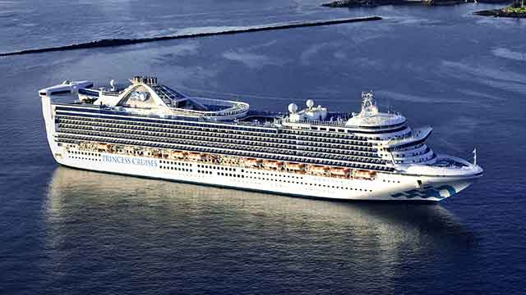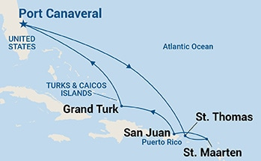
Princess Cruises Line
Sunday, March 23 – Monday, March 31, 2025
Ship Caribbean Princess
8-Night Eastern Caribbean Cruise
Roundtrip from Port Canaveral (Orlando), Florida

BB-Balcony – $2,350.80 per person (based on double occupancy)
B-Mini Suite – $2,737.28 per person (based on double occupancy)

CRUISE FARE – INCLUDES
- Cruise Fare
- Taxes, Fees, & Port Expenses
- PRINCESS PLUS
- Princess® complimentary dining and entertainment, MedallionClass® experience
- Wi-Fi (1 device per guest)
- Crew appreciation
- Plus – Beverage Package (drinks up to $15 each, includes unlimited juice bar)
- Fitness classes (2 per cruise)
- Premium desserts (2 per day),
- Travel Protection - Platinum Coverage Available upon request
- NEW – 2 Casual Dining Meals - per guest are Pre-Fixe Meals at Casual Dining Venues.
- NEW – Unlimited Juice Bar - available during Breakfast and Lunch during the opening hours of the World Fresh Marketplace
- Ocean Now APP and Room Service Delivery – One-Time Free delivery Access, usually a $14.99 fee per each guest

NOT INCLUDED
- Roundtrip Airfare
- Transfers ($50.00 per person roundtrip)

Deposit: $250.00 per person Final Payment Due: November 22, 2024

Cruise Itinerary:
Mar 23 Port Canaveral (Orlando), Florida Mar 28 San Juan, Puerto Rico
Mar 24 At Sea Mar 29 Grand Turk, Turks & Caicos
Mar 25 At Sea Mar 30 At Sea
Mar 26 St. Thomas, Virgin Islands Mar 31 Port Canaveral (Orlando), Florida
Mar 27 St. Maarten,
Any questions, please call Volare Travel, ask for Tracey Roe (586-263-4500) or cell (586-419-7959)
To secure your reservation
Email or Fax Registration/Credit Card Authorization form to Tracey@VolareTravel.com – fax (586-263-4221)

Registration & Credit Card Authorization Form
TIM AMES & LADY JULIE
FOR A CRUISE ABOARD THE CARIBBEAN PRINCESS
MARCH 23 -31, 2025
FOR A 8-NIGHT EASTERN CARIBBEAN CRUISE

To Secure Reservation – Please email form to Tracey@VolareTravel.com
If you have any questions call Volare Travel, ask for Tracey Roe. (586) 263-4500 & (586) 419-7959 cell

Date: Yacht Club:
Have you Sailed on PRINCESS CRUISES before? YES ___________ NO ________ MEMBER # ___________

First, Middle and Last Name – MUST be the same as on Passport.

1st Traveler: First Name Middle Name Last Name
Mailing Address City State Zip
Birthdate Cell Phone/Daytime Phone T-Shirt Size
Email Address

2nd Traveler: First Name Middle Name Last Name
Mailing Address City State Zip
Birthdate Cell Phone/Daytime Phone T-Shirt Size
Email Address

Choice of Cabin Category: Double: Single:
MINI SUITE (MB): ________ BALCONY (BB):______________________
Platinum Travel Insurance: Yes: No:

I hereby authorize Volare Travel Inc. to bill my credit card.
Name on Credit Card:

Credit Card Number (Last 4 digit’s): Expiration Date: Security Code:
Call office with complete credit card numbers

Address of Card:
City: State: Zip:

Signature as it appears on the card (s):

Deposit: $250.00 per person Final Payment Due: November 22, 2024

To secure your reservation
Email or Fax Registration/Credit Card Authorization form to Tracey@VolareTravel.com
If you have any questions call Volare Travel, ask for Tracey Roe (586-419-7959) Fax (586-263-4221)

