KING OF DIAMONDS RAFFLE
DETROIT BEACH BOAT CLUB LICENSE #C26975
Drawings will be held every Monday
Starting April 27th, 2015
At
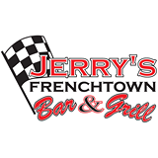
2932 N. Dixie Hwy
Monroe, MI 48162
Only $1.00 per ticket
Proceeds to help make marina improvements
60% of the pot goes to the winner
Tickets sold at Jerry’s and DBBC
