MIKE MAD DOG ADAMS
LIVE AT
HARBOR VIEW YACHT CLUB
6 pm till 11 pm April 16th 2016
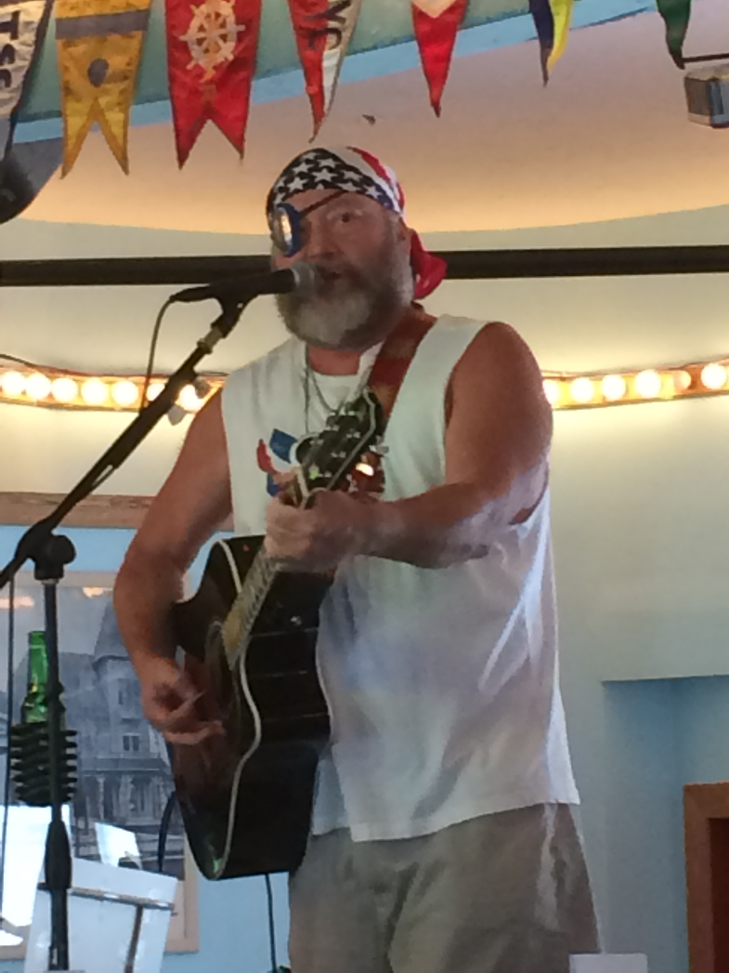
I/2 Chicken dinners will be available
Before the show from 5:30 – 7:00pm
DONATION AT THE DOOR FOR MAD DOG IS $5.00

