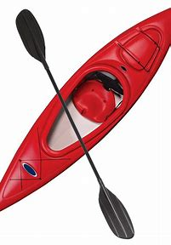

SWAN BOAT CLUB* IS HOSTING AN
“ANYTHING NAUTICAL” FLEA MARKET
Saturday April 22, 2023 9am – 4pm

$10.00 table rental (pay now or at the door
Bring all your nautical decorations, spare parts, extra lines, fenders, anchors, life jackets, sails, batteries, radios, GPS, paddles, fishing poles/gear, any nautical related etc.to sell.
Got a boat for sale? Bring pictures and information.
Call or text Ruth Demaggio at 734-905-3557
or sign-up sheet is behind the bar.
Donuts and coffee available for breakfast (by donation)
Goulash lunch w/rolls available for $5.00
*Swan Boat Club 6332 Brancheau Rd Newport, MI 48166 734-586-2002

