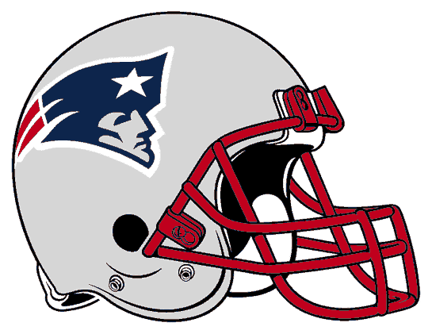 PARTY!! 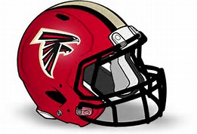
SUNDAY FEB. 5TH - Kick Off at 5:30
At 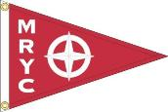Maumee River Yacht Club
Tailgate Menu
Half Time Entertainment by Lady Gaga!!
Come for the game or watch the commercials!!
