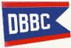
ANNUAL DBBC
TURKEY FRY
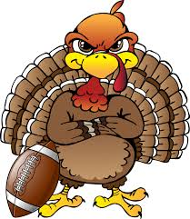

JANUARY 24th 6:00 PM
$12.00 PER PERSON
PLEASE COME JOIN US FOR A GOOD MEAL,
BASKET RAFFLES and, 50/50
AT THE FRIENDLEST CLUB ON THE LAKE.

