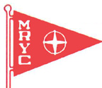
MRYC
Champagne Brunch Buffet
Sunday March 3rd
10:00 am – 2:00 pm

Please make a reservation at 419-382-3625 or at infor@mryc.us

Menu

Roast Beef
Spiral Cut Ham
Scrambled Eggs
Egg Casserole
Sausage/Bacon
Sausage Gravy & Biscuits
French Toast Bake
Fresh Fruit
Mashed Potatoes

$13.95 Adults w/reservation
$14.95 at the door
5.95 Kids 12 & under
Free for Kids 3 & under

