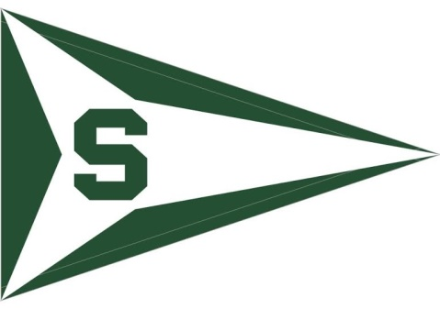
Michigan State University Sailing Club
Fundraising Dinner/ Silent Auction
Wednesday, March 23rd
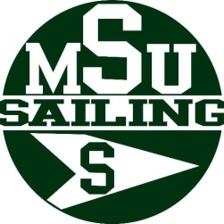
6pm-8pm @ Grosse Ile Yacht Club
Bolognaise & Alfredo Pasta will be served
$20 per person

The fundraising dinner is to help the Michigan State Sailing Club send a team to the EDHEC in Roscoff, France.
- Largest student offshore regatta in the world
- Draws over 3,000 sailors and 180 boats
- Last year more than 160 schools and universities from 23 countries were represented
- Dates back to 1969

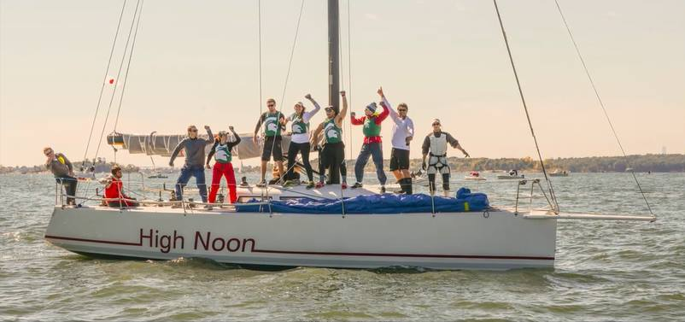
To RSVP Please contact msusail@msu.edu

If you cannot attend and would still like to contribute you can do so by going to https://www.gofundme.com/spartansailing
Follow us on Facebook (Michigan State University Sailing) to stay up to date with the regatta and other current events!

