Ford Yacht Clubs First Mates
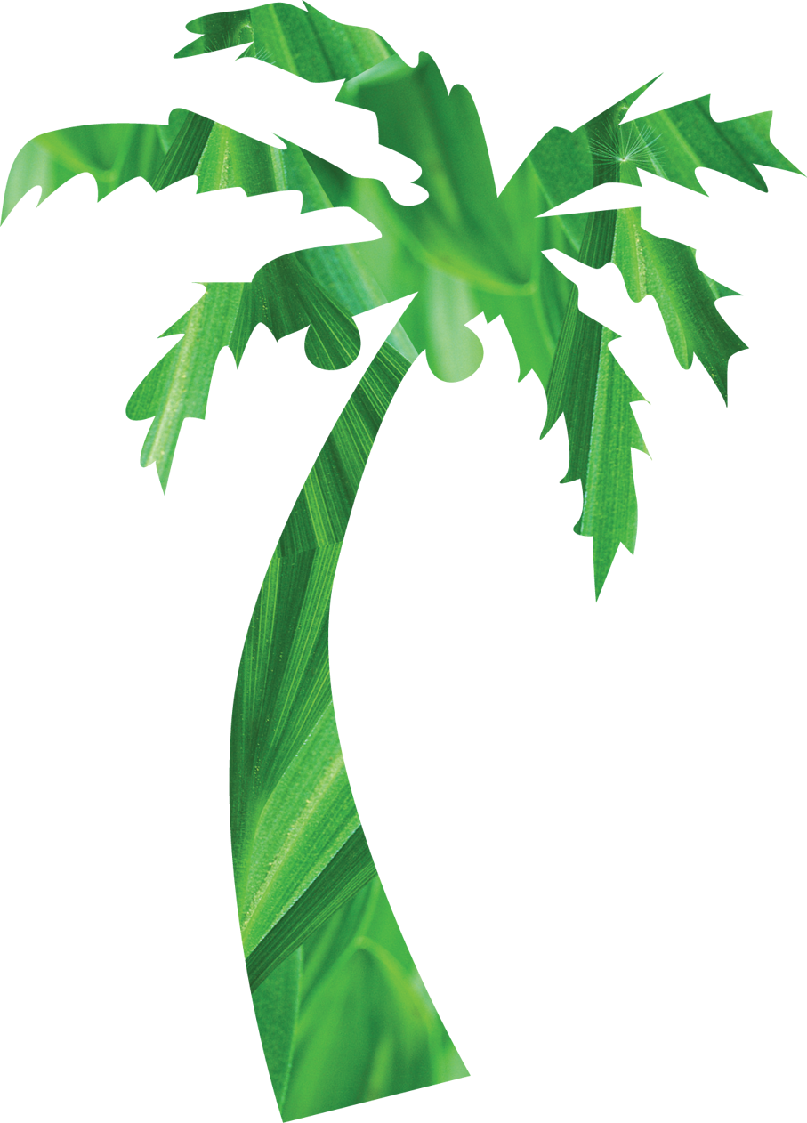Island Ladies
Fashion Show

Presented by the First Mates
May 14, 2014
6pm

Enjoy an evening with the ladies with fashions by

Country Enchantments

 FYC’s Ships Store

“Bag’s with Bling”

Dinner & Champagne:
Bistro Salad – Chopped Romaine and Mixed Greens, Red Pepper, Onion, Grape Tomatoes, English Cucumbers, Croutons, Sundried Cherries, Walnuts, Crumbled Blue Cheese, Bacon, Grilled Chicken and Apple Vinaigrette Dressing on the side


Specialty Homemade Dessert, Coffee & Tea

$25 Per Person
Contact Barb Takacs @ 734-558-6176
Or any member of the First Mates to get your tickets today!

