SWAN BOAT CLUB's
Blue Gavel & Past
Commodores
Memorial Day 2016 Rib Roast

FRIDAY May 27, 2016
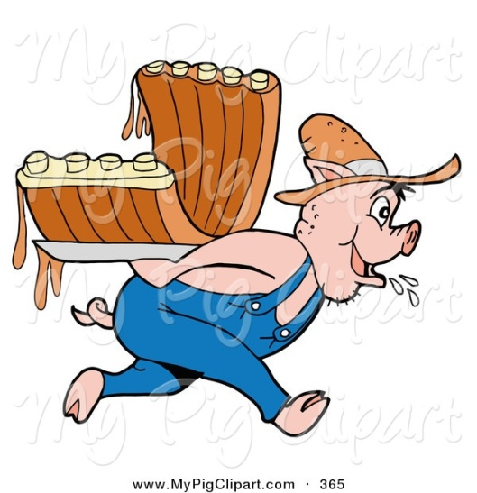
Butchered Another One
SOLD EVERYTHING BUT THE
BABY BACKS

Come and Pig out with us!

MODERATELY PRICED WITH ALL THE SIDES, FIXIN’S & DESSERT

**Dinner $10.00, NO RESERVATIONS, Come by boat & come early.

Dinner starts around 5:00PM
We will serve till 8:00pm or until they are gone!

