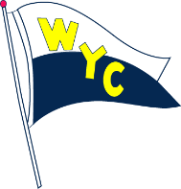
Join Us for a FUN FILLED EVENING
in
The Comedy Room @ Portofino
RSVP TO:
R/C Vivian Gebstadt
@ 313-682-4113 or david48@comcast.net

October 9, 2015

Time: Doors open at 7:30 p.m. Show Time: 8:30 p.m.  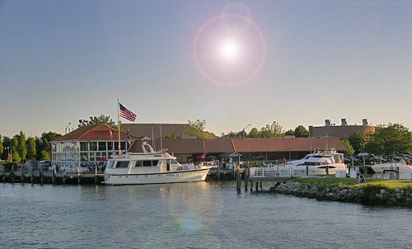 | The Comedy Room @ Portofino  Friday, October 9, 2015 8:30 PM  (doors open at 7:30)  To Benefit: WYC Yacht Club  $20.00 Must present ticket at the door  www.thecomedyroom.com  3455 BIDDLE STREET  WYANDOTTE, MI 48192 734-624-5561
Meet for Dinner . . . . . . Then Stay for the Show
Cash Bar Available During Show
Baskets to Raffle
50/50

WYC Apparel Encouraged

